Software Requirements Specification (SRS)
For
Smart Inventory System

Prepared by:
Manish Lad<253162>
Arpita Bakal<253122>
ASM's Institute Business Management and Research, Chinchwad, MCA, Pune

Guide Name: Prof. Prashant Kori
Guide Sign: _______________

Date: /03/2026

Table of Contents
1. Introduction …………………......................................................... 1
1.1 Purpose ………………........................................................... 1
1.2 Document Conventions .......................................................... 1
1.3 Intended Audience & Reading Suggestions ........................... 1
1.4 Project Scope .......................................................................... 1
1.5 References .............................................................................. 2
2. Overall Description ......................................................................... 2
2.1 Product Perspective ................................................................ 2
2.2 Product Features ..................................................................... 2
2.3 Operating Environment .......................................................... 3
2.4 Design and Implementation Constraints ................................ 3
2.5 Assumptions and Dependencies ............................................. 3
3. System Features (Modules Description) ......................................... 4
4. External Interface Requirements ..................................................... 6
4.1 User Interfaces ........................................................................ 6
4.2 Hardware Interfaces ................................................................ 6
4.3 Software Interfaces ................................................................. 6
4.4 Communications Interfaces .................................................... 7
5. Other Nonfunctional Requirements ................................................ 7
5.1 Performance Requirements .................................................... 7
5.2 Software Quality Attributes ................................................... 8
6. Other Requirements ........................................................................ 8

1. Introduction

1.1 Purpose
This document specifies the software requirements for the Smart Inventory System (Small Shop Version). Smart Inventory System is a desktop application being developed to help small retail shops manage their stock, handle billing operations, and generate business reports efficiently. The system will handle activities including product and category management, real-time inventory tracking, automated billing with GST calculation, low stock and expiry alerts, sales recording, and comprehensive report generation.
This SRS covers the complete application including all modules that are planned for development. The system is designed for a single retail shop deployment and will work on local computers without requiring internet connection. All data will be stored in a local MySQL database which provides better performance and complete control over business information.

1.2 Document Conventions
In this document we have followed standard conventions for writing SRS. The font used throughout is Times New Roman with 12 point size. The word "shall" is used to indicate mandatory requirements that must be implemented in the system. The word "should" indicates recommended features that add significant value. Technical terms are explained when they appear for the first time in the document.
All modules and features have been numbered properly so that they can be referenced easily during development and testing. High priority requirements are those which are essential for basic functioning of the system. Medium priority requirements add significant value but system can operate without them in the initial version.

1.3 Intended Audience and Reading Suggestions
This document has been prepared keeping in mind different types of readers. For developers who will be coding the system, Section 3 and Section 4 contain detailed technical specifications about modules, interfaces, and system behavior. Project guide and evaluators can refer to Section 2 which gives overall project description, constraints, and assumptions.
For testing the application, Section 3 describes all modules and their expected behavior in detail. Section 5 defines quality standards and performance benchmarks that need to be verified during testing. We suggest that all readers first go through Section 1.4 to understand the project scope, then read Section 2 for the overall system overview, and finally study Section 3 for detailed functionality specifications.

1.4 Project Scope
Smart Inventory System is a desktop software being developed to help small retail shops manage their inventory and billing operations efficiently. Currently most small shops use manual paper registers or basic spreadsheets for tracking stock which leads to errors, inefficiency, and loss of business information. Our system solves these problems by providing an integrated automated solution.The main goals of this project are to create a platform where shop administrator can manage product catalogue and categories, staff can perform billing operations quickly and accurately, stock levels are automatically maintained and monitored, alerts are generated for low stock and near-expiry products, and comprehensive reports can be generated for business analysis. The system focuses on simplicity, accuracy, and reliability so that even non-technical shop owners can use it effectively.

1.5 References
For developing this project we have referred to various sources. Java SE documentation has been very helpful for understanding core Java programming and Swing GUI components. JDBC documentation helped in understanding database connectivity. MySQL documentation was useful for database design and query optimization.
We have referred to software engineering textbooks to understand how to write proper requirements specifications. Information about inventory management best practices was gathered from various retail management articles and research papers. iText library documentation was consulted for PDF generation requirements.

2. Overall Description

2.1 Product Perspective
Smart Inventory System is a completely new system being built from scratch. It is not replacing any specific existing software but rather providing a digital alternative to the manual paper-based systems currently used by small shops. The system will work as a standalone desktop application on the shop's computer. Main components include the graphical user interface created using Java Swing, business logic layer written in Java, JDBC layer for database communication, and MySQL database for storing all information.
The system does not require any web hosting or internet connectivity. It will run locally on the computer where it is installed. This design makes it suitable for small shops that may not have reliable internet connection or that want complete local control over their business data.

2.2 Product Features
The system includes several important features grouped into modules. For administrator operations, there is complete product and category management with full CRUD operations. The inventory management feature tracks real-time stock levels and handles stock additions. The billing module provides fast invoice generation with automatic GST calculation. The alert system monitors stock levels and product expiry dates and displays warnings. The sales module records all transactions and maintains complete sales history. The report module generates various business reports and exports them as PDF files.

2.3 Operating Environment
The application will run on desktop computers or laptops. Minimum hardware requirements are Intel Core i3 or equivalent processor, 4 GB RAM, 1 GB free disk space for application and database storage, and a display with minimum 1024 x 768 resolution. The application will be compatible with Windows 7 and above operating systems. Compatibility with Linux Ubuntu is also targeted.
Users will need Java Development Kit (JDK) version 8 or above installed on the system. MySQL Server version 5.7 or above is required for the database. MySQL Connector/J JDBC driver must be included in the application. iText library for PDF generation will be bundled with the application. Standard keyboard and mouse will be used for all input operations.

2.4 Design and Implementation Constraints
As per project requirements, Java must be used as the programming language. Java Swing has been chosen as the GUI framework for creating desktop interface. JDBC is used for database connectivity. MySQL is the selected database management system. These are fixed technology choices that must be followed throughout development.
The system is designed for single shop deployment only. Multi-shop or multi-branch support cannot be implemented in the current version. Another constraint is that data must be stored locally and cloud storage or remote access is not included. Since this is an academic mini project, development time is limited to one semester. The system must function without any internet connectivity for all core features.

2.5 Assumptions and Dependencies
We assume users have basic computer knowledge and can operate desktop applications. The shop must have at least one computer meeting the minimum system requirements, and staff will receive basic training before deployment.
The system requires JDK 8 or above and MySQL Server installed and running on the same computer. Regular database backups and proper security software are assumed to ensure data safety and prevent unauthorized access.

3. System Features (Modules Description)

Module 1: Admin Module
This module is the entry point and control center of the system. Administrator login verifies credentials entered by the shop owner or manager. Username and password are stored in database with password encrypted using hashing algorithm. If login credentials are incorrect, system shows appropriate error message. Session is maintained until admin explicitly logs out or closes the application.
After login, admin accesses the product management section. Admin can add new products by filling a form with fields for product name, category, unit of measurement, purchase price, selling price, GST rate percentage, and minimum stock quantity. All fields are validated before saving. System checks that product name is not duplicate in the same category. Admin can search for existing products by name or category and edit any product details. When a product is no longer sold, admin can deactivate or delete it from the system.
Category management is also part of this module. Admin can create new product categories like Groceries, Electronics, Stationery, Medicines, and so on. Categories can be renamed or removed if no products are assigned to them. Organizing products into categories makes searching and reporting much more meaningful and manageable.

Module 2: Inventory Management Module
This module is responsible for maintaining accurate stock records for all products. The primary function is tracking current stock quantity for every product in real time. When new stock is purchased from supplier and needs to be added to system, admin opens the stock addition form. Admin selects the product, enters quantity received, purchase price, batch number, and expiry date if applicable. System updates the product's current stock quantity immediately upon saving.
The module displays current inventory status in a tabular view showing all products with their current quantity, minimum stock level, and status indicator. Products with stock below minimum level are highlighted in red color for immediate visual identification. Admin can filter the inventory view by category or search by product name.
For products like medicines and perishable food items, the module tracks expiry dates at batch level. Each stock addition is recorded as a separate batch with its own expiry date. System checks expiry dates regularly and marks batches as near-expiry when they are within the configured alert threshold days.

Module 3: Billing Module
This module handles all customer sales transactions at the shop counter. Billing staff accesses this module after logging in with staff credentials. The billing interface shows a product search box and a cart area. Staff types product name or scans barcode in the search box and matching products appear as suggestions. Staff selects the product and enters quantity. System automatically calculates line total based on selling price and quantity.
Staff can add multiple products to the cart before finalizing the bill. At any point items can be removed from cart or quantities can be edited. When all items are added, staff clicks the Calculate button. System calculates subtotal for each item, applies GST at the rate configured for each product, and computes grand total including all taxes. GST breakup is shown separately on the invoice as required by GST regulations.
When staff confirms the bill, system generates a formatted invoice with unique bill number, date and time, list of items with quantities and prices, GST details, and grand total. Invoice can be printed on paper receipt. Simultaneously the system reduces stock quantities of all billed products from inventory and records the complete transaction in the sales database. This automatic stock update ensures inventory is always accurate.

Module 4: Sales Module
This module maintains complete record of all sales transactions processed through the billing module. Each transaction record contains bill number, date and time of transaction, list of products sold with quantities and prices, GST amount, and total bill amount. Records are stored chronologically with indexing for fast retrieval.
Admin can view sales records for any selected date or date range. The sales list shows all transactions with basic details and admin can click on any transaction to view complete bill details. System calculates daily totals, weekly totals, and monthly totals automatically from the stored records.
The module identifies most frequently sold products by analyzing sales history. This information is displayed as top selling products list which is useful for making stock decisions. Products that have not been sold in a long time are also identifiable from sales history which helps in managing slow-moving inventory.

Module 5: Alert and Notification Module
This module serves as the monitoring and warning system of the application. It runs checks whenever the application starts and periodically during operation. Two types of alerts are generated by this module based on inventory and expiry data.
Low Stock Alert is generated when the current quantity of any product falls below or equals the minimum stock level defined by admin for that product. This minimum level is configured individually for each product based on its consumption rate and reorder lead time. When a low stock alert exists, the system shows a notification badge on the main dashboard. Admin can view complete low stock report listing all products that need to be reordered along with current quantity and minimum required quantity.
Expiry Alert is generated when any product batch has an expiry date that is within the configured alert period. By default system alerts for products expiring within 30 days but this threshold can be changed by admin. Expiry alerts show product name, batch number, quantity in that batch, and the expiry date. This allows shop owner to take action by running promotions on near-expiry stock or returning to supplier before expiry.
All active alerts are displayed prominently on the admin dashboard home screen so that critical information is immediately visible when admin logs in. Alerts are cleared automatically once the underlying condition is resolved, for example when stock is replenished or expired batch is removed.

Module 6: Report Module
This module handles all reporting and analysis. The admin selects a report type and parameters (like date range or category), and the system generates a formatted report from the database. Reports can be exported as PDF using iText.
The Stock Report shows current inventory with quantity, prices, total value, and highlights low stock items.
The Sales Report displays transactions for a selected period with totals, bill count, average bill value, and top-selling products.
The Monthly Report summarizes total sales, cost, gross profit, profit margin, and top-performing products.
The Low Stock Report lists items below minimum level to guide reordering.

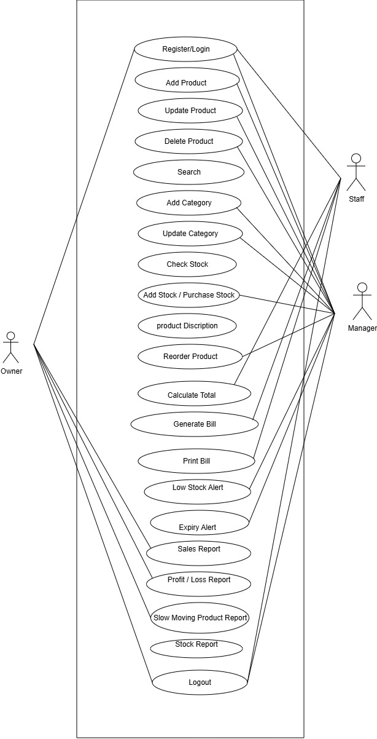Use-Case Diagram:

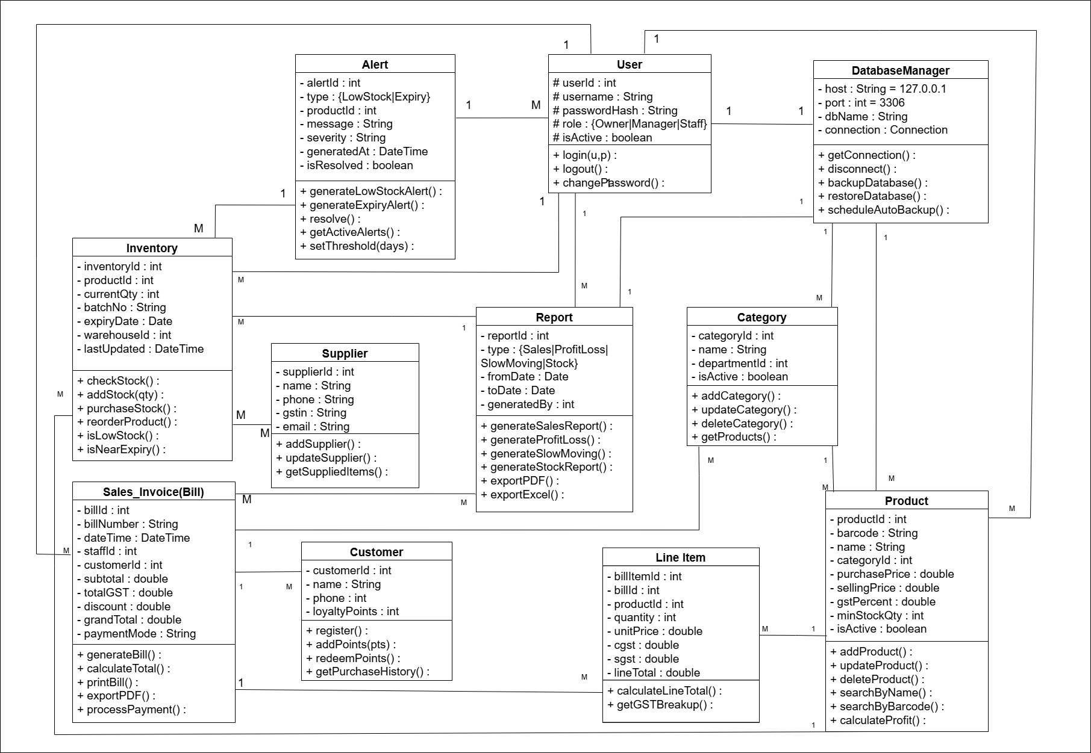Class Diagram:

Object Diagram:

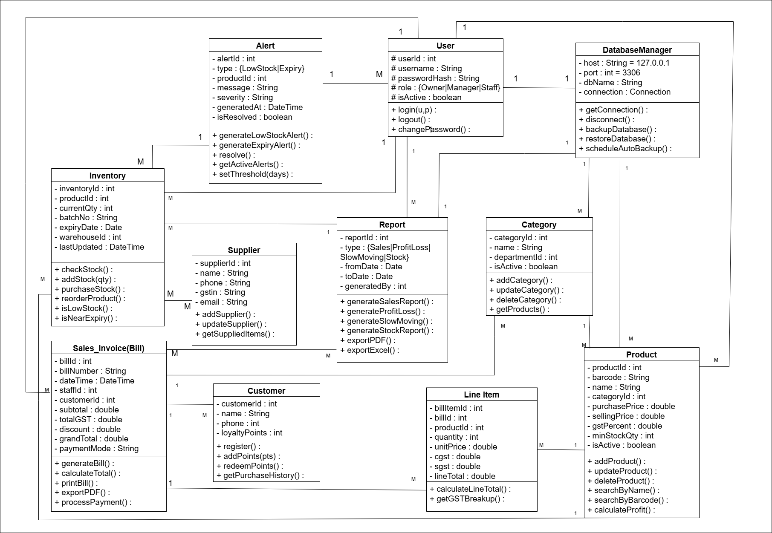`

4. External Interface Requirements

4.1 User Interfaces
The system will use clean and professional Java Swing interfaces. The main window will include a menu bar (Products, Inventory, Billing, Sales, Alerts, Reports) and a dashboard showing today’s sales, low stock alerts, and expiry alerts.
A login screen with username and password fields will appear at startup, showing red error messages for invalid credentials. Admin can create staff accounts. Data entry forms will include proper labels, input validation, highlighted error fields, green success messages, and confirmation prompts for critical actions.
Tables will use JTable with sorting, search filters, pagination, and low stock highlighted in light red. All screens will have consistent button placement and 12-point font, with standard keyboard navigation support.

4.2 Hardware Interfaces
The system requires a keyboard and mouse/touchpad, along with a monitor of at least 1024×768 resolution.
A printer is needed to print invoices and reports using Java’s standard printing API, though users can save them as PDFs if no printer is available. For future use, a USB barcode scanner (works like a keyboard input device) can be connected without special drivers.
Data is stored on the local HDD/SSD, with at least 1 GB free space recommended. A USB drive or external hard disk can be used for regular database backups.

4.3 Software Interfaces
The application is built on Java SE platform and requires JDK version 8 or above to be installed on the deployment computer. Java 8 introduced many improvements and is still widely supported making it a safe baseline version requirement. Java Swing library which comes bundled with JDK is used for all user interface components.
MySQL Server version 5.7 or above must be installed and running on the same computer. MySQL Connector/J version 8.0 JDBC driver is used to establish connection between Java application and MySQL database. The JDBC driver JAR file is included with the application distribution so it does not need to be separately downloaded.
iText library version 5.x is used for generating PDF invoices and reports. This library JAR file is also bundled with the application. No additional software is required for PDF generation. Generated PDFs can be opened with any standard PDF reader like Adobe Acrobat Reader.
The application interacts with the operating system through Java's standard libraries for file operations, printing, and system dialogs. No direct operating system API calls are made which ensures cross-platform compatibility across Windows and Linux.

4.4 Communications Interfaces
The system works completely offline and does not require any network or internet connection for any of its core functions. All data communication happens locally between the Java application and the MySQL database server running on the same machine through localhost connection (127.0.0.1) on standard MySQL port 3306.
Database connection is established when the application starts and maintained throughout the session. Connection pooling is not required for this single-user application. If database connection fails due to MySQL service not running, application shows a clear error message instructing the user to start MySQL service.
For data backup, database dump files generated by MySQL export function can be transferred to backup storage devices using standard file transfer operations. No special communication protocols are needed for backup and restore operations. Reports exported as PDF files can be shared via email or other means externally but this external sharing happens outside the scope of the application itself.

5. Other Nonfunctional Requirements

5.1 Performance Requirements
The system shall provide fast response during all operations, especially during peak billing hours. Application startup (including database connection) shall complete within 5 seconds, and login authentication within 2 seconds.
Form submissions, data saving, bill generation, and database queries (up to 10,000 records) shall complete within 2–3 seconds. Simple reports shall generate within 5 seconds, complex monthly reports within 10 seconds, and PDF exports within 5 seconds.
Memory usage shall not exceed 512 MB RAM, and the system shall remain responsive at all times. If any operation exceeds 3 seconds, a progress indicator shall be displayed.

5.2 Software Quality Attributes
The system ensures high reliability by maintaining data integrity through proper transaction management. Any error during stock or sales updates will trigger automatic rollback, and the system will handle errors gracefully without crashing.
Usability is prioritized with consistent layouts, clear labels, simple error messages, and quick access to common tasks. New users should perform basic operations after brief training.
For security, passwords are stored using SHA-256 hashing, role-based access control restricts features by user type, parameterized queries prevent SQL injection, and inactive sessions require re-authentication.
The system follows a modular layered architecture (UI, business logic, DAO) for easy maintenance, with clear naming and proper documentation.
It is portable across Windows and Linux, using Java and MySQL’s cross-platform support and OS-independent file handling.

6. Other Requirements
Database backup is essential to protect valuable business data. The system will provide a built-in feature to export the full MySQL database as a timestamped SQL dump file. Admin can perform manual backups, enable automatic backup at startup, and restore data when needed.
All business data will remain private and accessible only through secure login. Sensitive information like pricing and profit margins will be restricted to admin users and stored only on the local computer.
The code will follow a modular package structure (UI, services, DAO, models, utilities) for easy maintenance and future expansion.
Complete documentation will include a user manual, admin guide, installation guide, and troubleshooting section. Shop staff and administrators will receive basic training before deployment, along with quick reference guides and technical support details

